**3.a. Create table PageView:**

Create table page_view(page_id int,user_id int,time string)

**Create table User:**

Create table user(user_id int,age int,gender string)

**Insert values into Page_view:**

insert into table page_view

values('1','111','9:08:01'),('2','111','9:08:13'),('1','222','9:08:14')

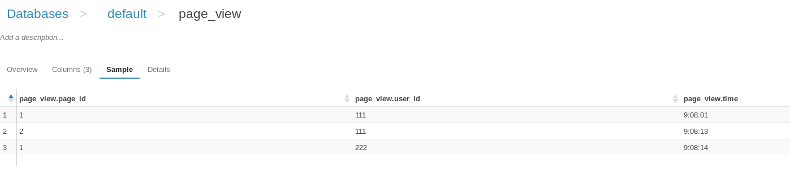

**Insert values into User:**

insert into table user

values('111','25','Female'),('222','32','Male')

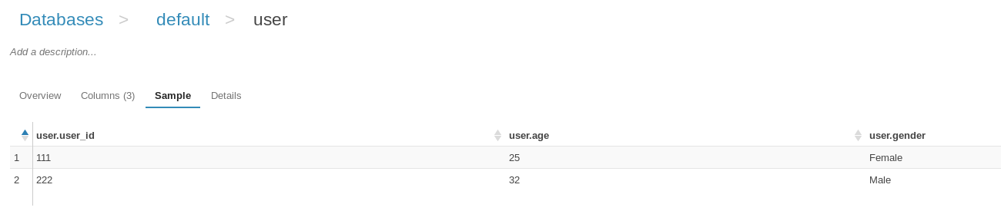

**Joining the two tables:**

Joining two tables

create table pv_users as select page_view.page_id,user.age from page_view inner join user on (page_view.user_id = user.user_id)

